Assignment -4 Python Programming

|  |  |
| --- | --- |
| Assignment Date | 01 November 2022 |
| Student Name | E.Arish krishna |
| Student Register number | 142219106013 |
| Team ID | PNT2022TMID21747 |

SMS SPAM CLASSIFICATION

Import the necessary libraries

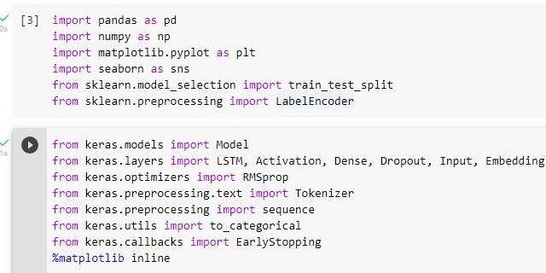

Download the Dataset

Dataset Downloaded and uploaded to drive [https://www.kaggle.com/code/kredy10/simple-lstmfor-](https://www.kaggle.com/code/kredy10/simple-lstm-for-text-classification/data) [textcl](https://www.kaggle.com/code/kredy10/simple-lstm-for-text-classification/data)assification/data

Read dataset and pre-processing

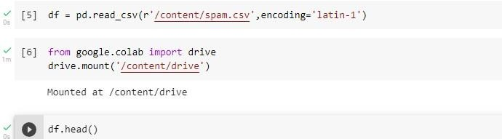

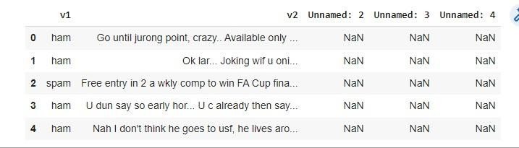

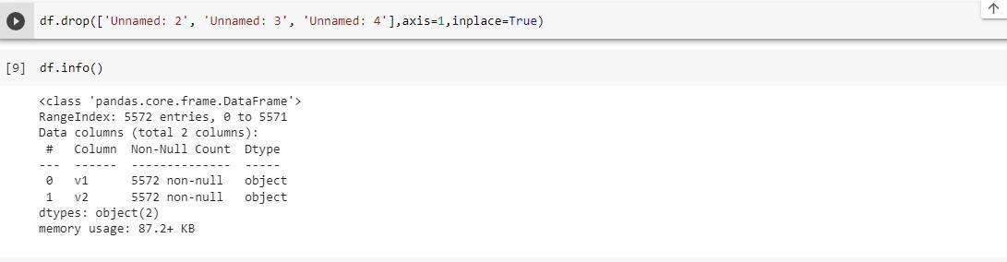

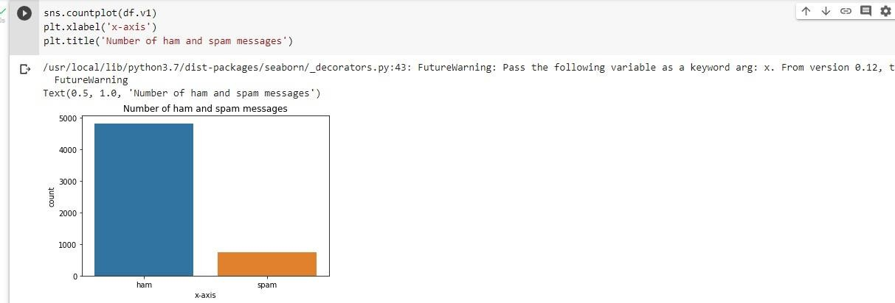

Create input vectors and process labels

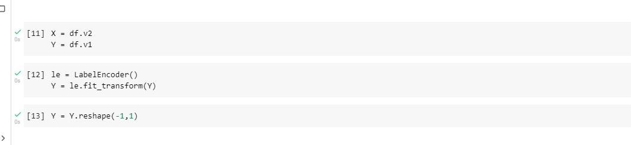

Split the training and testing data

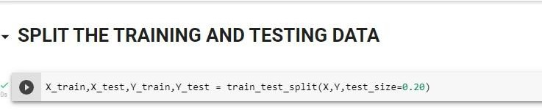

Process the data

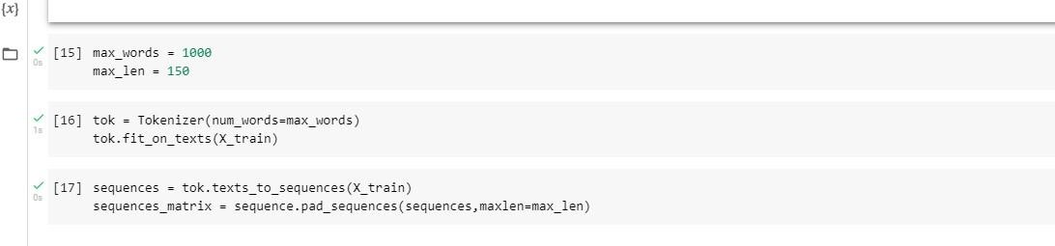

Create models and add layers

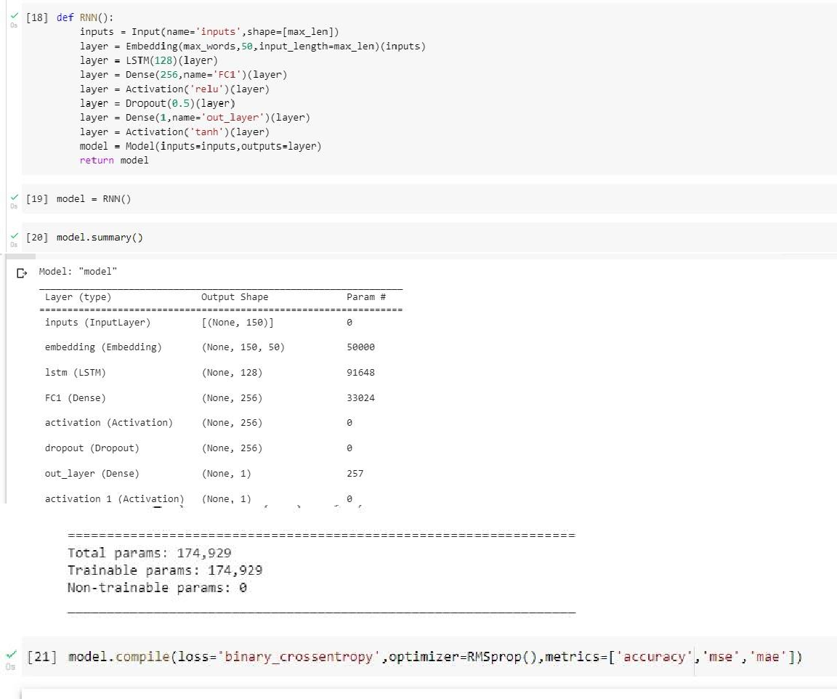

FIT THE MODEL

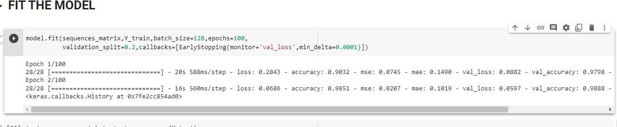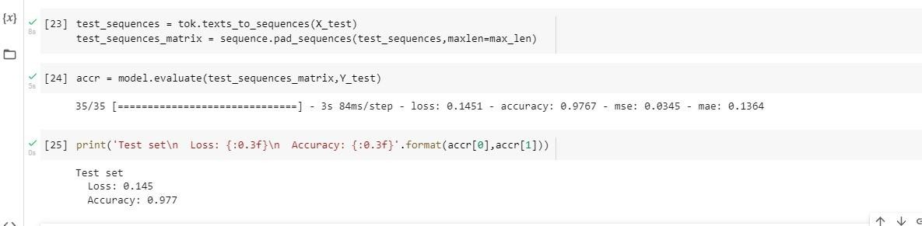

SAVE THE MODEL

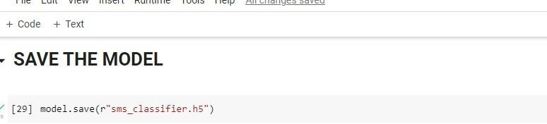

TEST THE MODEL

